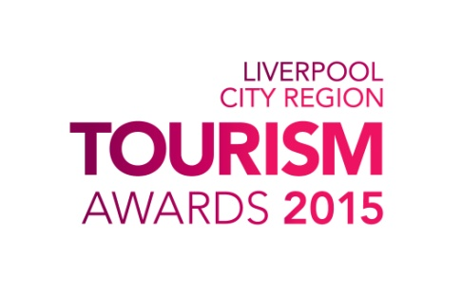
The Winners!

Bar of the Year - Sponsored by Marketing Liverpool
The Brink

Best Newcomer to the Visitor Economy - Sponsored by Eventful
Seecret Tours

Excellence in Business Tourism - Sponsored by ACC Liverpool
The Foresight Centre - University of Liverpool

Guest Accommodation of the Year - Sponsored by Tamzyn Angela
Mere Brook House

Hotel of the Year - Sponsored by Liverpool John Lennon Airport
Hope Street Hotel

Independent Tourism Business - Sponsored by Liverpool City Region LEP
Shiverpool

Large Visitor Attraction of the Year - Sponsored by Davy Liver Taxis
Knowsley Safari Park

People's Choice
The Cavern Club

Performance Venue of the Year - Sponsored by MSP
Liverpool Everyman and Playhouse

Serviced Apartment of the Year - Sponsored by Cleanall
Staybridge Suites Liverpool

Small Visitor Attraction of the Year - Sponsored by Wild Thang
Port Sunlight Museum

Taste Liverpool - Sponsored by Natwest
Delifonseca Dockside & Fonseca's

Tourism Event of the Year - Sponsored by Liverpool ONE
Giant Spectacular

Tourism Experience of the Year - Sponsored by Liverpool Hoteliers Association
Shiverpool

Tourism Marketing Campaign of the Year - Sponsored by Influential
Liverpool Biennial

Individual Awards

Outstanding Customer Service - Sponsored by Liverpool BID Company
Kasia Psiuk - Bistro Qui

Tourism Young Person of the Year - Sponsored by L20 Hotel School
Daniel Heffy - The Art School Restaurant

Tourism Ambassador of the Year - Sponsored by WebTicketManager
Kerrin Macphie – ACC Liverpool

Outstanding Contribution to Tourism
Hilary Oxlade – Blue Badge Guide

